Risk Game

Made by:

Medhat Ashraf Abdo Alhaddad

Hazem Hamada Abdellatif

Ahmed Abdalla Mohamed Madany

**Description**

The game is called Risk. Risk is a strategy board game of diplomacy, conflict and conquest for two to six players. The standard version is played on a board depicting a political map of the earth, divided into territories, which are grouped into six continents. Turn rotates among players who control armies of playing pieces with which they attempt to capture territories from other players, with results determined by dice rolls. Players may form and dissolve alliances during the course of the game. The goal of the game is to occupy every territory on the board and in doing so, eliminate the other players. The game can be lengthy, requiring several hours to multiple days to finish. The game starts by distributing countries and soldiers. The game was implemented in Java language.

The game was implemented by creating classes for Missions, Players, Countries and Tiles. The game has 3 phases: Deploy, Attack and Reinforce. At the beginning of the game.

The game is design: at first the Players are created using an array list, countries are distributed on each player, and country colors are set according to players who own them. Then, the each player can distribute his soldiers to countries as the player desires before the game begin(to transfer to the other player the player must press the “next round” button) ,then the first player is asked to deploy his new soldiers(equals to the number of his countries /3 + if he have a continent he will get additional soldiers (Asia=7,africa=3,ausytalia=2,Europe=5,southAmerica=2,northAmerica =5)) in his countries using the (okDep method in the code) then when he press the “next round” button he will be transferred to the attacking phase ,in this phase the player must choose two adjacent countries and one of them must be in his own by selecting the countries from the map, after that he must chose from the scroll bar the number of soldiers he will attack by, the number of soldiers must be more than the number of soldiers on the country he will attack from with at least one soldier ,then he must press on the ok button and “attack” method will activate ,the dices will roll randomly if the dice’s values of the attacker are more than the defender one or two soldiers(depends on the number of the defender’s soldiers) from the defender will die, otherwise the attacker’s so if the number of defender’s soldiers is equal to zero the attacker player will be the owner of this country and its color will change to the new player’s color, then the attacker soldiers will be moved to the attacked country. The player can repeat on any adjacent country to any country he owns (note: he can’t attack from a country that has only one soldier, to select another country he must deselect the selected country first.). when the player finish from attacking he will press the “next round” button to transfer to the reinforcement phase, in this phase the player have to select two adjacent countries in his own, then he selects the number of players he want to transfer from target1 to target2 from the scroll bar, then press “ok” button ,then the “reinforcement” method will transfer the soldiers from target1 to target2, then press the “next round” button to move to the other player to do all the above again(deploy->attack->reinforce).

Note: to open the jar file you must open it from its location with the fame.txt file to read from it.

**User Guide**

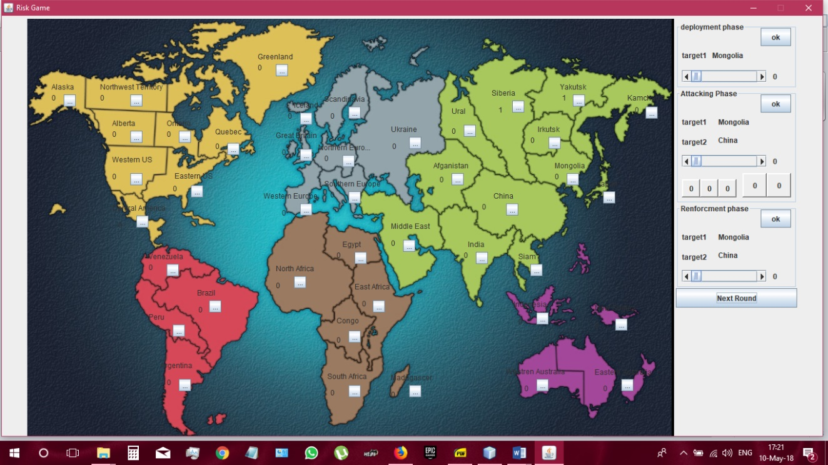This is the user guide for the Risk game. Below is a screenshot of how the game looks like before the start.

**1.Start**

At the beginning of the game, number of players and player names are entered. Then, Countries are divided among players, soldiers, and each player gets a number of soldiers, depending on the total number of players. The first player distributes their soldiers among their countries in first deployment by selecting a country, number of soldiers to deploy, and clicks on the country again to remove selection. Then, they select another country, and so on until all the soldiers are deployed in their respective countries. The player then clicks on “Next Round” for the second player to do the same, and so on until all players have initially deployed their 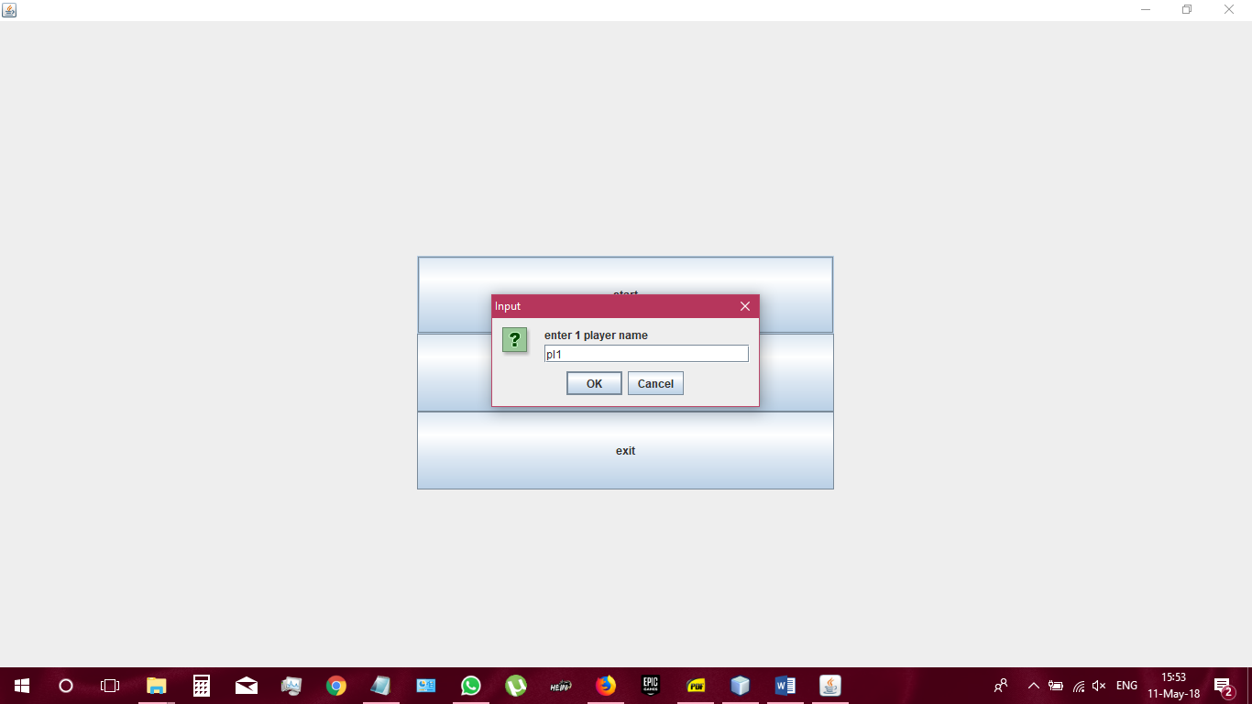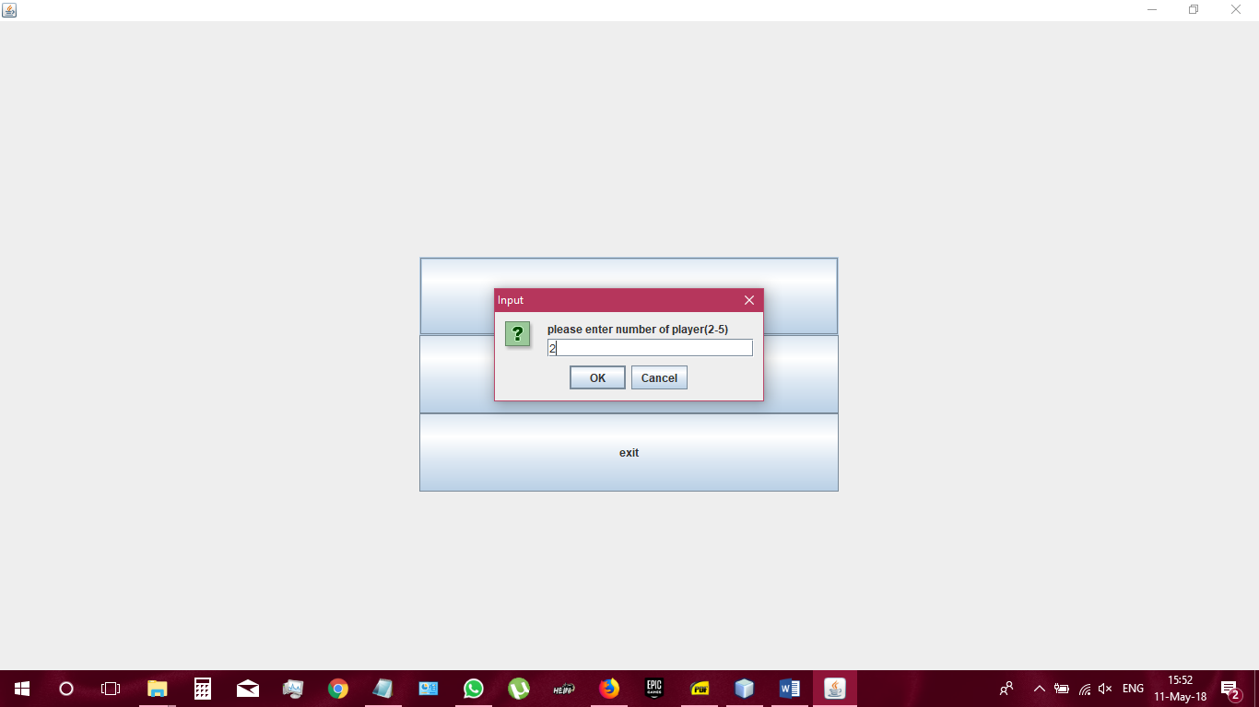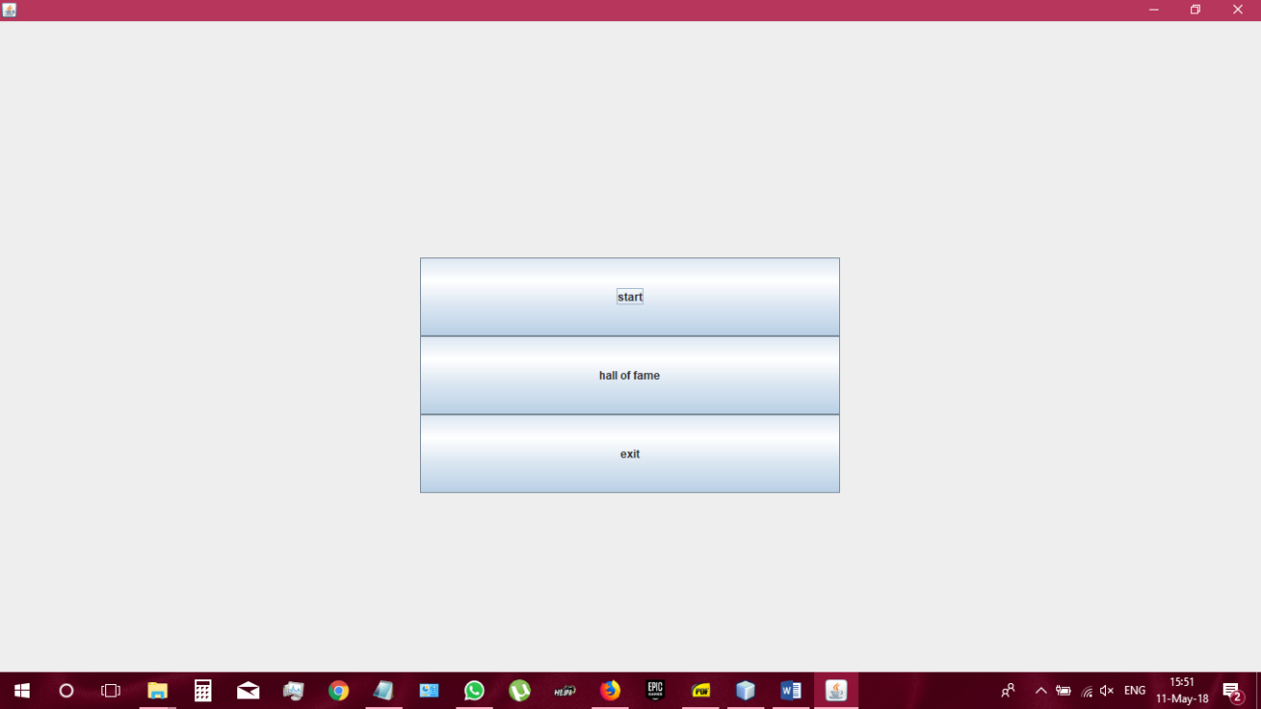soldiers. “Next Round” starts the game.

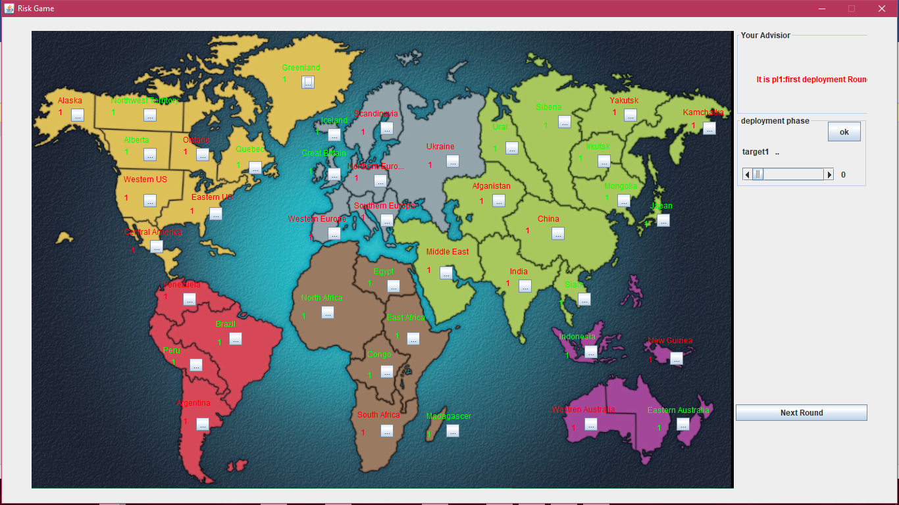

|  |  |
| --- | --- |
| **No. of players** | **No. of soldiers/player** |
| 2 | 40 |
| 3 | 35 |
| 4 | 30 |
| 5 | 25 |
| 6 | 20 |

**2.Deployment Phase**

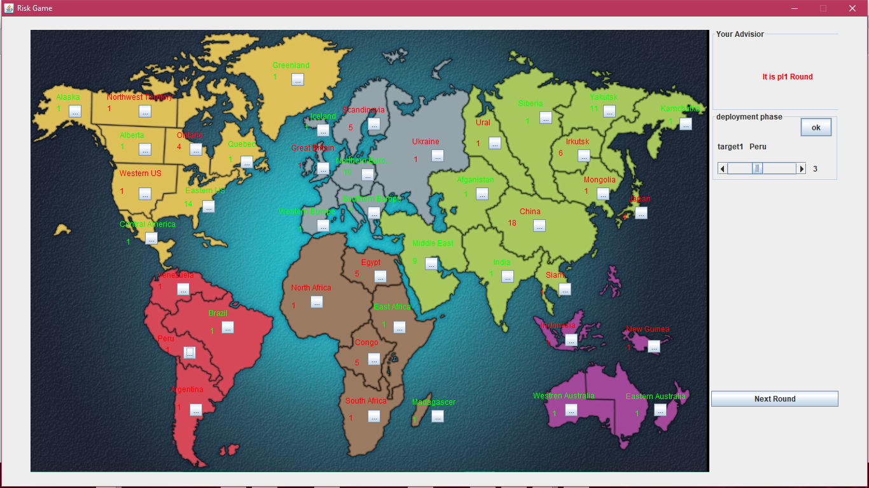For each player turn, there are 3 phases, first of which is Deployment Phase. The player clicks on any country that is owned by them (**target1**) and chooses the number of soldiers to be deployed using the scroll bar, then clicking on the “Ok” button. Click on “Next Round” button.

**3.Attacking Phase**

After the soldiers are deployed, the attack phase begins. The player must first choose the attacking country (**target1**), then choose the country to attack (**target2**), number of soldiers to do the attack. Remember that the country to be attacked must be adjacent to the attacking country, and the number of soldiers in the attacking country must be 2 or more (at least one soldier must be left in the country). Click on “Ok”.

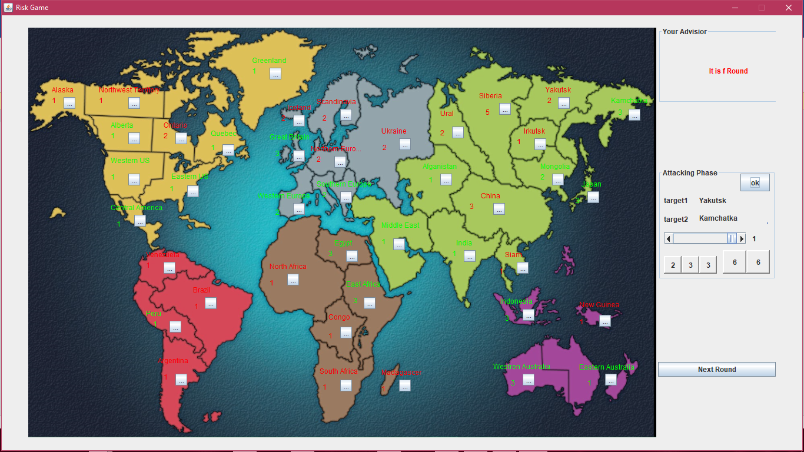

The attack begins by rolling dice and comparing their results. The attacking player can roll up to 3 dice, whereas the defending player can roll a max. of 2 dice. When the dice are thrown, the values of the attacking dice are compared to the ones of the defending dice, greater values together then the lower ones. If the attacking player is attacking with one soldier, only one die is played. If the attacking die/dice are greater than the defending, 2 soldiers are removed from the defending player’s country and vice versa. In case of a draw, 1 player is removed from each of the players’ countries. If the defending country is left with 0 soldiers, then it now belongs to the attacking player and they can move a desired number of soldiers from their country to the other country, provided that there should be at least one soldier remains in the first country. Click on “Next Round”.

**4.Reinforcement phase**

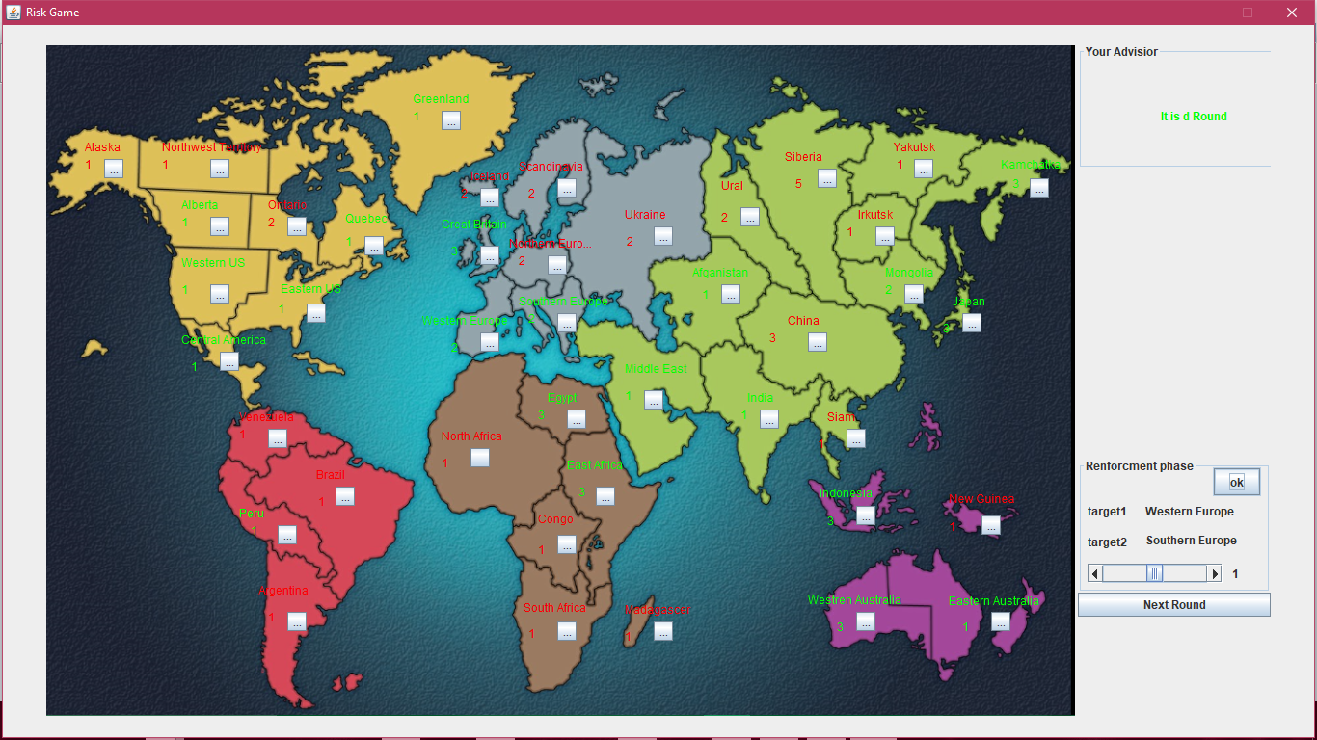In this phase, the player has a choice to reinforce their country of choice, by moving any number of their soldiers to an adjacent country occupied by them, provided that at least one soldier remains in the first country. The player chooses the first country (**target1**), second country (**target2**) on the map, number of soldiers to move, and clicks “Ok”.

The player’s turn is now done, and the next player begins their turn. After all the players have finished their turns, “Next Round” button is clicked, and the next round starts. This goes on until any of the players complete their mission, or occupy all the countries on the map, thereby winning the game.

**Hall of fame:**

To see the winners over the previous games you can click on the “hall of fame” button from the start menu.

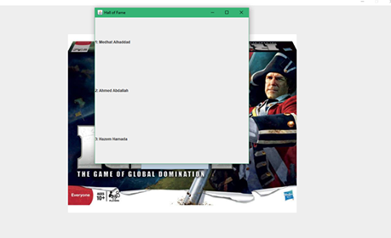

Work Distribution

This project was distributed among the team members in the following way:

Medhat Ashraf Abdo:

**Report**, testing, country and tiles classes, deployment method, attack method, reinforcement method, GUI.

Hazem Hamada Abdellatif:

Report, testing, country and tiles classes, player class, Deployment method, attack method, next round method.

Ahmad Abdallah Mohammad:

Report, testing, soldiers class, player class.